Presenters
Bryce Peterson
As an award-winning business executive, Bryce H. Peterson continues to push the traditional boundaries and stereotypes of business and IT leadership. Mr. Peterson joined Universal Technical Institute in October 2008 and has served in various leadership capacities throughout the organization; he is currently serving as Chief Financial Officer and Chief Information Officer and has responsibility for Corporate Compliance. Prior to joining UTI, Mr. Peterson served in a variety of positions at KPMG, LLP, Brigham Young University, and Fenton Enterprises. Mr. Peterson has been published multiple times and was recognized with Microsoft’s Visionary Award in 2015 and as a finalist for Phoenix Business Journal’s CIO of the Year in 2013. Mr. Peterson is a Certified Public Accountant licensed in the State of Arizona and received an MS in Information Systems Management and a BS in Business Management from Brigham Young University.
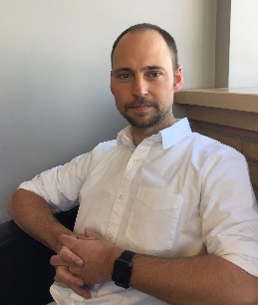
Aaron Nieboer
Always looking for new ways to improve user engagement regardless of industry, Aaron Nieboer melds his technical expertise with his passion for the creative. Since co-founding BrokenMyth Studios in 2007, he has served as the Creative Director responsible for delivering innovative solutions for clients such as Johnson and Johnson, Chobani, BMW and Xerox. Universal Technical Institute acquired BrokenMyth Studios in early 2016 and Aaron continues his responsibilities as Creative Director. Prior to joining Universal Technical Institute, Mr. Nieboer has worked both freelance and in the gaming industry as a concept artist, art director, designer and 3D modeler. He has a BFA in New Media from Columbus College of Art and Design.
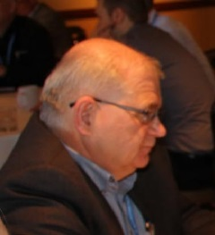
Ken Benson
Part of the automotive industry since 1976, Ken became involved in technical training, and has worked in the OE realm, since 1988. His current responsibilities at Subaru of America include: Training Field operations, training facilities, Subaru-University, and curriculum/course development. “I enjoy the evolution of the industry and the inherent challenges associated with change.”
Larry Posey
Larry Posey is a Project Manager at TTi Global, with hands-on technical experience from Chrysler dealerships. Based on his years of experience as a technician, Larry understands the learner engagement challenges faced by automotive training developers. This experience and understanding has helped Larry to develop courses in both Web-Based Training (WBT) and Instructor-Led Training (ILT) format. He holds an Associate Degree in Applied Science Automotive Technology and is progressing through a Bachelor’s Degree focusing in management. Larry is also a member of The Project Management Institute (PMI).

Dr. Anuja Sonalker
Dr. Anuja Sonalker is the founder and CEO of STEER Tech, LLC, which develops self-driving car technology. STEER is focused on building products that will massively enable situationally aware, cyber robust automated driving. Dr. Sonalker brings together experience from both the automotive industry as well as the cyber security sector. Prior to STEER, Sonalker was V.P of Engineering and Operations for TowerSec, an automotive cyber security company that was acquired by Harman International in 2016. Prior to TowerSec, she headed the Automotive Security Group in the Cyber Innovation Unit at Battelle, where she led advanced research in vehicular environments and transition to market strategies.
During her career Dr. Sonalker has established collaborative research efforts and strategic partnerships, provided project management and helped set the strategic direction for the commercialization of technology. Dr. Sonalker is currently the Vice Chair of the SAE Vehicle Cybersecurity Systems Engineering Committee and a subject matter expert on the joint ISO-SAE Automotive Security Engineering Committee. Dr. Sonalker is committed to developing our next generation workforce and mentors young women and high school children to pursue careers in engineering. She holds a PhD in Electrical Engineering from the University of Maryland College Park, and a Master of Science in Computer Engineering from North Carolina State University.
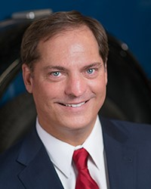
Donny Seyfer AAM
Immediate Past Chairman of the Automotive Service Association and Co-Owner of Seyfer Automotive in Wheat Ridge, CO, with more than 35 years of automotive experience as a technician, manager, and service consultant. Donny is an initiative leader for the ASA Telematics Connected Car project, a member of the Aftermarket Telematics Task Force, Board Member for the National Automotive Service Task force, and Board of Governors member for the National Automotive Technician’s Education Foundation. As an ASE Master / L1 Advanced Diagnostic Technician and C1 Service Consultant and he has served as an ASE subject matter expert on numerous occasions, developing content standards and participating in test question writing. He is a contributing editor to Babcox Publications, Aftermarket News, Autobody Repair News, Motor Age, Delmar / Cengage, and the ASA AutoInc magazine.
Jennifer Maher
Jennifer Maher has enjoyed a 25-year career in strategic alliances and marketing, having served on the senior leadership team for Make-A-Wish America, YMCA of the USA and The Nature Conservancy. She's been a consultant to nonprofit clients including Boy Scouts of America, ChildFund, Conquer Cancer and Habitat for Humanity. Jennifer has personally negotiated strategic alliances valued at more than $100 million with companies including General Motors, BMW, PepsiCo, Kimberly-Clark, Sports Illustrated, NASCAR, Macy's and Harley Davidson. Today, Jennifer serves as CEO of TechForce Foundation, a nonprofit dedicated to championing students to and through their education, into careers as vehicle technicians -- and driving the FutureTech Success campaign to solve the technician shortage.

