Leadership in the work, looking at a small portion on a class we delivery to our BMW dealer network. As our technician move to lead technician, shop foremen or team leader, how can we support them with the move to a leadership position.
Presentation:
Part of being a leader is trusting your team and your team trusting you. We will look at “Trust”, What is the meaning of trust? Building trust amongst your team can produce a more productive team. Below is part of the presentation where we include the participants, what does high/low trust look like? and outcomes of High/Low trust teams.
Time 10-15min
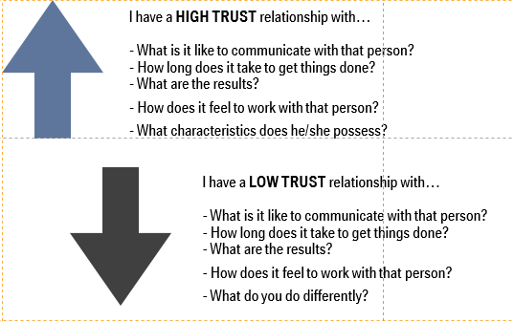
Building trust is part on someone’s credibility. We define credibility in four parts. Building blocks of trust. Time :10-15min
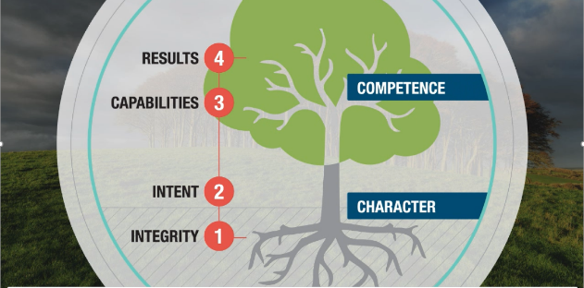
Conclusion to presentation, A brief look into leadership training BMW offers our dealer workshops, and how we integrated this process into our training department personnel and programs. Time: 10-15min
Q&A session following presentation

